## Generate Aortic Valve Mesh in LS-PrePost

### Import CAD Surface Model

1. Import File: File 🡪 Import 🡪 STEP File (aorticheartvalve3.stp)
   1. Default Unit is mm! Use scale factor 0.1 for cm.
2. Identify model parts in positive X-Y-Plane: View 🡪 Top, Unblank all other parts
3. Save as Project File, “geometry.proj”
4. Model Clean Up:

* Aorta: Remove unnecessary Vertexes on Surface Edges: Curve 🡪 Merge 🡪 Piecewise, Remove Raw Edge
* Stitch Surfaces of Leaflet and Aorta Surfaces: GeoTol 🡪 Stitch (Black Line shows stitched surfaces), Use non-manifold mode to stitch edges between 3 surfaces as well.
* Clean Up Commissure Surface: Add Missing Line on Commissure Part on Z=0 Plane by
  1. Projecting Circle on Surface: Curve 🡪 Circle, Radius R=30,
  2. GeoTol 🡪 Project 🡪 Conical Projection, Select Circle and Surface
  3. Trim Commissure Surface on Z=0 Plane: GeoTol 🡪 Trim, Use Projected Circle as Trim Tool
* Save Project

### Create Leaflet Shell Mesh (Const Thickness)

1. Unblank all but Leaflet Surfaces
2. Divide Leaflet Surfaces:
   1. Create Break Points on Surface Edges: Curve 🡪 Break 🡪 Parameter, N-Segment=2, Only Create Break Points, For Free Edge, Z-Plane Trajectory, Basal Attachment Edge and Belly Symmetry Curve.
   2. Create Break Point on Belly Surface: Curve 🡪 Point, Click on Surface, Try to get centre of Surface. (0.7753508 cm, 0.5085122 cm, -0.3476466 cm)
   3. Connect Break Points: Curve 🡪 Line 🡪 Point/Point
   4. Project Break Lines onto Surfaces: GeoTol 🡪 Project 🡪 Normal Projection.
   5. Subdivide Surfaces: GeoTol 🡪 Trim 🡪 MultiTrim
   6. Stitch Surfaces and Remove unnecessary vertexes if needed!
   7. Rename new Shell Surface Container
3. Reflect Surfaces: GeoTol 🡪 Transf 🡪 Reflect, Plane 🡪 Norm Y, Copy
4. Stitch SurfacesEin Bild, das Diagramm, Kreis, Reihe, Design enthält.

   Automatisch generierte Beschreibung
5. Mesh Leaflet: Mesh 🡪 NLineM 🡪 4LinesShell
   1. Select Edges Counterclockwise starting on right edge (Element Direction will thus be upwards towards Free Edge)
   2. Use Ratio 1.02 and 0.98 to create better quad ratios.
   3. Contact Region Centre: 12x10
   4. Contact Region Basal Attachment: 11x10
   5. Belly Region adjacent to Contact Region: 11x10
   6. Belly Region in Contact to Basal Attachment: 12x11
   7. Belly Region Center: 12x10
   8. Sum: 592*2*3=3552 🡪 Aspect Ratio < 1.48. With worst elements near basal attachment.
   9. Check Element Direction: EleTol 🡪 EleEdit 🡪 Direction Ein Bild, das Muster, Rechteck, Kunst, Mosaik enthält.

      Automatisch generierte Beschreibung
   10. Check Normal Direction: EleTol 🡪 Normal
   11. Remove Duplicate Nodes: EleTol 🡪 DupNod, Show, Merge, Accept
   12. Combine to one Part: EleTol 🡪 MovCop 🡪 Click All, PID=1
   13. Optional: Smooth Surface: EleTol 🡪 Smooth, Click Smooth, Accept
   14. Save as Project: geometryLeafletShell
6. Create Shell Section: Model 🡪 Keywrd 🡪 Section, Shell, T1=0.5 Enter
7. Assign Section to Part and Delete old Parts: Model 🡪 Keywrd 🡪 Part, Section=1
8. Show Thickness: Model 🡪 Appear 🡪 Thick, AllVis, Done

### Create non-uniform thickness Leaflet

1. Create Areas of different thickness: EleTol 🡪 MovCop
   1. For Belly, For Basal Attachment, For Free Edge
   2. Intermediate Layers in between areas above for gradual change of thickness.

Ein Bild, das Screenshot, Text enthält.
Ein Bild, das Grün, Flagge enthält.

1. Smooth Leaflet Surface (optional): EleTol 🡪 Smooth
   1. Lock Nodes 🡪 Click Nodes on corner between free edge and Commissure and at bottom of symmetry line 🡪 3 points!
   2. Select Elements 🡪 Click all elements
   3. Smooth Option: 🡪 Untick Feature Angle, Lock Boundary and Project Back
   4. Iterations = 20 (Maybe less)
   5. Smooth, Accept
   6. Smooth Surface Deviations with respect to original geometry
      1. At Symmetry Line: Between 0 and 0.074 cm. Increasing towards free edge. 🡪 Max. 3,1% with respect to Heart Valve Diameter. Average: 0.023 cm 🡪 0.96%
      2. At Directrix Curve: Between 0 and 0.07 cm. Decreasing towards Symmetry Curve 🡪 Max 2,9% with respect to Heart Valve Diameter. Average: 0.036 cm 🡪 1,5%
      3. At Free Edge: Between 0 and 0.066 cm. Increasing towards Symmetry Line 🡪 Max 2,75% with respect to Heart Valve Diameter. Average: 0.0067 cm 🡪 0,28%
      4. At Basal Attachment: Between 0 and 0.07 cm. Decreasing from Intersection Point of Commissure and Directrix Curve towards Free edge and symmetry Line. 🡪 Max. 2.75%. Average:

Ein Bild, das Text, Screenshot, Diagramm, Reihe enthält.

1. Assign different thickness: EleTol 🡪 EleEdit 🡪 Modify 🡪 Uniform Thickness to Shell, By Part. Use 0.05 mm difference in thickness for adjacent layers.

1. Create Solid from Shell: Mesh 🡪 EleGen 🡪 Solid 🡪 Shell_Thickness, Segment = 3. Unblank Delete Shell.
2. Smooth Free Edge (Optional) 🡪 EleTol 🡪 Smooth
   1. Select Elements 🡪 ByPath 🡪 Choose Elements on Free Edge on Fibrosa and Ventricularis Side. Only one Layer!
   2. Lock Nodes 🡪 By Part 🡪 Choose all. Click on Rm and choose nodes on free edge of Fibrosa and Ventricularis. Don’t Remove the points on the Commissure of the free edge! Iterations =3.
   3. Adjust nodes on Commissure: EleTol 🡪 Transf 🡪 Translate 🡪 N1-N2, Distance = 0.016 (First Picture below)
   4. Adjust nodes on Symmetry Line at Basal Attachment: Distance 0.004 in upward direction (N1 to N2) See Picture below. 0.002 in direction towards inner Belly.
   5. Ein Bild, das Muster, Kunst, Design enthält.

      Automatisch generierte Beschreibung Ein Bild, das Kunst enthält.

      Automatisch generierte Beschreibung mit mittlerer Zuverlässigkeit

### Create Solid Valve Surface

1. Create Shell Mesh for the upper and lower faces of the volume mesh:
   1. Mesh 🡪 EleGen 🡪 Shell by Solid Face
   2. Create 4 Surfaces for Fibrosa (Use original shell to see where the boundary of each part must be)
   3. Create 4 Surfaces for Ventricularis
   4. Create 4 Surfaces for Basal Attachment
   5. Create 6 Surfaces for Free Edge

Ein Bild, das Kunst, Design enthält.
Ein Bild, das Kunst, Design enthält.
Ein Bild, das Flugzeug, Heißluftballon, Transport, Ballon enthält.

1. Create Surfaces from Shell mesh
   1. Surf 🡪 FitSuf 🡪 Select by Part
   2. MaxTol = 0.0001, Smoothness decreased to min (left position of slider)
   3. Preview 🡪 Fit 🡪 Apply
   4. Do this for all 18 Parts
   5. Check Each Surface and make sure that the boundaries are represented exactly!
   6. For the Free edge a different approach must be used. Create Wires like in the picture below using Curve 🡪 Line 🡪 Point to Point

Ein Bild, das Reihe, Steigung enthält.

Surf 🡪 NSide 🡪 Select by Area, Use Simple Fit

1. Add Vertices on the corners of every Surface: Curve 🡪 Break 🡪 Click Edge, Mayb you must decrease the Max angle.
2. Merge edges to remove vertices on the edges which are no corner points: Curve 🡪 Merge 🡪 Piecewise, Remove Raw Edge.
3. Stitch the surfaces one by one: GeoTol 🡪 Stitch

### Create Aortic Root Surfaces

1. Create new Sinus
   1. Create three circular arcs (red, blue, green) using the original Sinus geometry (Brown Surface) and the newly generated Valve surfaces.

Curve 🡪 CircArc 🡪 3 Points

Ein Bild, das Design enthält.

Make sure to use the highest valve point for the blue arc.

* 1. Trim The three arcs: GeoTol🡪Trim 🡪 Standard

Ein Bild, das Grün, Farbigkeit enthält.

* 1. Create Sinus Surfaces: Surf 🡪 N-Side 🡪 Continuity0 🡪 AutoClose. Make sure to include the small edge on the free edge

Ein Bild, das Grün enthält.

* 1. Stitch surfaces: GeoTol 🡪 Stitch 🡪 Non-manifold mode. Pink lines show edges stitched to more than one other surface. Here three surfaces are stitched together at one edge.

Ein Bild, das Grün enthält.

* 1. Create 4 Circles using all the original shell elements

Ein Bild, das Ball enthält.

* 1. Mirror the Created Shell: GeoTol 🡪 Transform 🡪 Rotate 🡪 Use whole shell as entity 🡪 Direction=z 🡪 Angle 120° 🡪 Copy Instances = 2

Ein Bild, das Text, Screenshot, Diagramm, Design enthält.

* 1. Create two more circles for the bottom of the leaflet (brown) and the commissure of the leaflet (Yellow): Curve 🡪 Circle 🡪 3 points.

Ein Bild, das Ballon, Heißluftballon, Ball, Grün enthält.

* 1. Trim the circles for the interleaflet triangle. Use Multi Trim Option

Ein Bild, das Screenshot, Text, Design enthält.
Ein Bild, das Text, Screenshot, Reihe, Farbigkeit enthält.

Ein Bild, das Text, Screenshot, Grafikdesign, Design enthält.

* 1. Create the interleaflet surfaces: Surf 🡪 Nside 🡪 Continuity 0, untick all checkboxes. You might have to change the order of the members in the edge list to get the correct result.

Ein Bild, das Text, Screenshot, Diagramm, Reihe enthält.

Create the part between the leaflets the same way but this time use auto close.

Ein Bild, das Text, Screenshot, parallel, Reihe enthält.

* 1. Rotate/Mirror the interleaflet triangles and Stitch the surfaces.

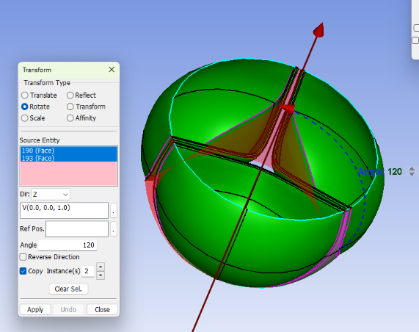

* 1. Use original Shells to generate the red and the blue straight lines. Use the lowest point on the leaflet as first point of line and lowest point of original shell as second point. Trim the brown and green circle using the red and blue line. And create the surface using the N-Side feature as before.

Ein Bild, das Heißluftballon, Ballon enthält.
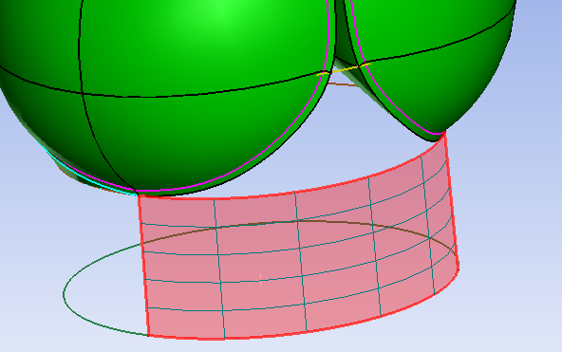

* 1. Repeat step k for the Aorta Part

Ein Bild, das Himmel, Spielplatz, draußen enthält.
Ein Bild, das Himmel enthält.

* 1. Use the circles at the top and bottom of the geometry and create inlet and outlet using N-Side Surface

Ein Bild, das Design enthält.

* 1. Delete unnecessary parts. Only keep one Sinus, Leaflet, Interleaflet triangle, as well as 1/3 of top and bottom part.

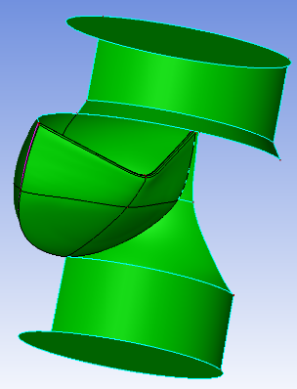

### Create Smoothed Aortic Root Surfaces

* Stitch interleaflet triangle and inlet region (grey region)

Ein Bild, das Design enthält.

* Stitch aortic region (grey)

Ein Bild, das Cartoon, Design, Kunst enthält.

* Mesh the surfaces from 1. And 2. Using Mesh 🡪 AutoM 🡪 Mixed 🡪 Compute 🡪 Mesh. Create one Mesh for grey parts of step 1 and one mesh for grey parts of step 2

Ein Bild, das Text, Screenshot, Grafiksoftware, Design enthält.
Ein Bild, das Kunst enthält.

* Smooth created meshes.

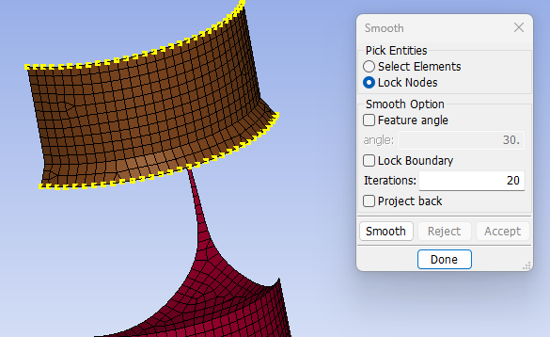Ein Bild, das Text, Screenshot enthält.
Ein Bild, das Kunst, Design enthält.

* Use Surf 🡪 Fit Surf 🡪 MaxTol = 0.0001, Smoothness = min, Preview 🡪 Fit and Apply on the two generated meshes from step 4 separately.

Ein Bild, das Grün, Design, Kunst enthält.

* Create a ref Plane and trim the Interleaflet triangle

Ein Bild, das Grün, Design, Kunst enthält.

Smooth Surface Deviations with respect to original geometry:

Ein Bild, das Text, Screenshot, Diagramm, Karte enthält.

* At Commissure Symmetry Line

Max: 0.036 cm 🡪 1.4%*, Average: 0.0098 cm 🡪 0.41%*, biggest difference above sinus

* At Sinus Symmetry Line

Max: 0.047 cm 🡪 1,96%*, Average: 0.00651 cm 🡪 0.27%*, biggest difference above sinus

* Use Merge Curve and Break Curve to eliminate vertices on edges and create vertices on corners.

Create The Aortic Root Mesh for FEM

Rotate/Mirror the Shell Meshes representing the basal attachment area. Blank all other shell and volume meshes, since they will cause problems connecting boundary nodes automatically when meshing.

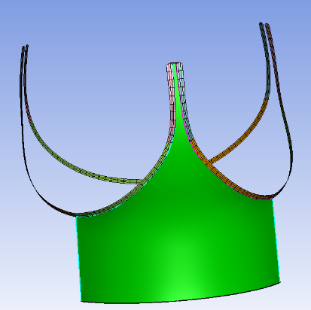 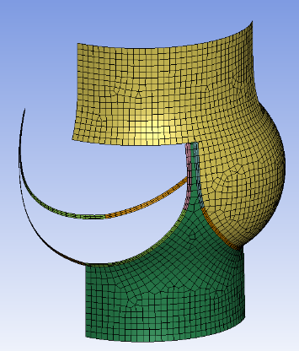

Start Meshing the aortic root parts. Create one part for the annulus (green Part) and one for the Sinus and ascending aorta. Mesh 🡪 AutoM 🡪 Size 🡪 Mixed 🡪 Compute 🡪 Connect Boundary Nodes 🡪 Mesh and Accept. You might have to increase the Merge Tolerance

Oberflächen für gmsh anpassen.

* Zwei halbe Segel wie in dem Bild durch Reflect und Rotate Mirror erzeugen
* Inlet und Outlet dritteln. Dazu z-Achse erstellen, Punkt auf Achse zeichnen und auf Oberfläche projizieren. Danach zwei Linien vom Kreismittelpunkt zur Aorta ziehen, Mergen und die Oberfläche trimmen. Unnötige 2/3 Flächen löschen.
* Durch Break Curve Vertex zwischen den beiden geraden Kanten erstellen.

Ein Bild, das Text, Screenshot, Design enthält.
Ein Bild, das Grün, Design enthält.

* File 🡪 SaveAs 🡪 SaveGeomAs 🡪 STEP

### VI Fluid Mesh Generation in Gmsh

1. Open Gmsh.exe
2. Import Step File: File 🡪 Open 🡪 Choose File
3. Adjust graphical representation: Tools 🡪 Options 🡪
   1. Geometry 🡪 Visibility 🡪 Surfaces
   2. Mesh 🡪 General 🡪 Max element size = 0.1
   3. Mesh 🡪 General 🡪 Visibility 🡪 2D Faces
4. Create Basic Mesh: Mesh 🡪 1D 🡪 2D
5. Adjust Mesh Density: Mesh 🡪 Define 🡪 Size at Points 🡪 Click Points and enter element size
   1. When you are asked to create new Geo file click Create new .geo file.
   2. Open the geo file in notepad++ and update.
   3. Adjust the comments in the geo file such that you know which region is related to which mesh density
6. Export Mesh: File 🡪 Export 🡪.key